CA 3 – CAP447

Section - D2112
Roll No – B81
Registration No – 12108348
Name – Aniket Kumar
Subject – Data Warehousing and Data Mining Laboratory

Task – Apply Classification Model on dataset

Dataset used – Teaching Assistant Evaluation (tae) dataset

Operators used -
- Set Role – to change the role to label
- Multiply – to split the data in two parts, one is going to Optimize Parameters and other is going to Compare ROCs
- Optimize Parameters (Grid) – to find optimal values of selected parameters inside the subprocess
- Select Subprocess – This operator contains multiple subprocesses, but it executes only one subprocess at a time
- Remember – It stores the given object in the object store of the process
- Cross Validation – It performs a cross validation to estimate the statistical performance of a learning model
- Decision Tree – It generates a decision tree model, which can be used for classification
- Random Forest – It generates a random forest model, which can be used for classification
- Rule Induction – It learns a pruned set of rules with respect to the information gain from the given ExampleSet
- Apply Model – It applies a model on an ExampleSet
- Performance (Classification) – It is used for statistical performance evaluation of classification tasks
- Compare ROCs – It generates ROC charts for the models created by the learners in its subprocess and plots all the charts in the same plotter for comparison
- Recall – It retrieves the specified object from the object store of the process
- Set Parameters – It applies a set of parameters to the specified operators
Process
- Retrieve tae dataset
- connect Set Role Operator to it. In Parameters set attribute_name to Faculty_Performance and target role to label.
- Connect Multiply operator to Set Role.
- Connect Optimize Parameters (Grid) to the Multiply operator.
- In Parameters, go to Edit Parameter Settings. Here, Operator-Select Subprocess and Parameters-select_which.
- Connect per and par output ports of Optimize Parameters to the result port.
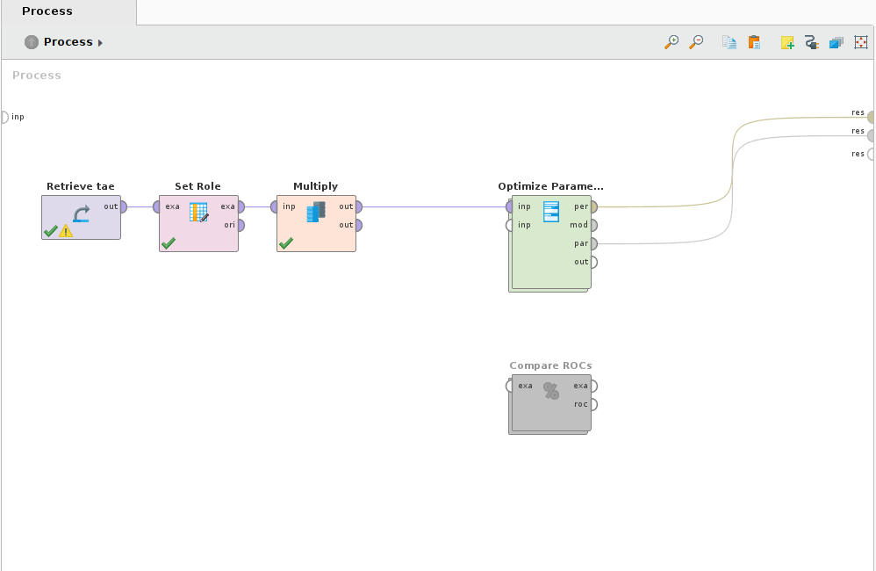
- Double Click on Optimize Parameters and add Select Subprocess Operator to it.
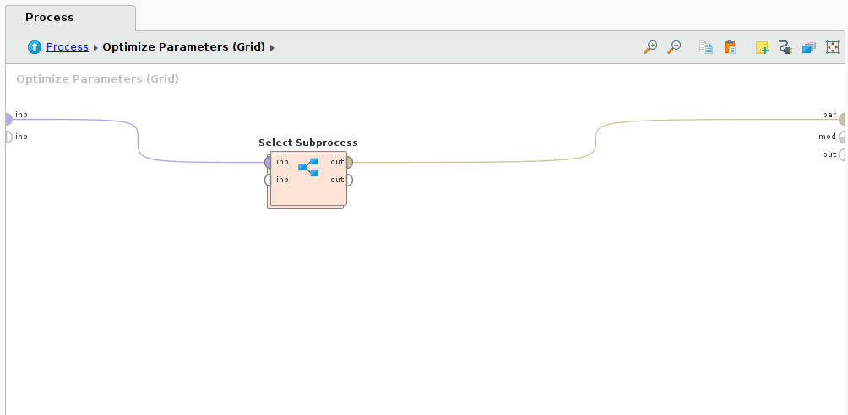
- Double Click on Select Subprocess operator.
- Here we have to add 3 different classification models using Optimize Parameters operator and connect Remember Operator to each of them.
- Parameters of Remember operator are: name-any name and io to ParameterSet.
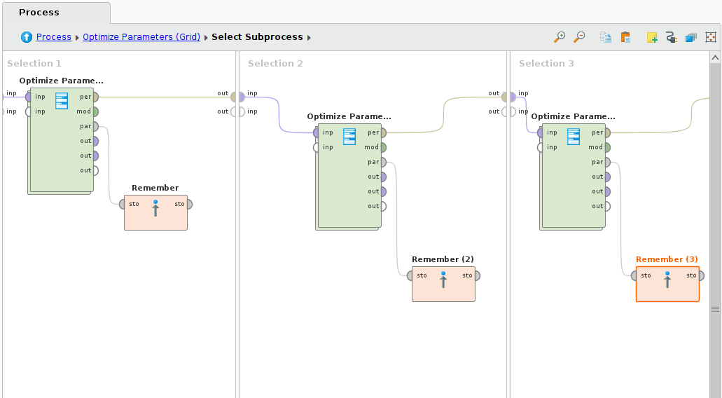
- Inside Optimize Parameters, we have to add Cross Validation operator.
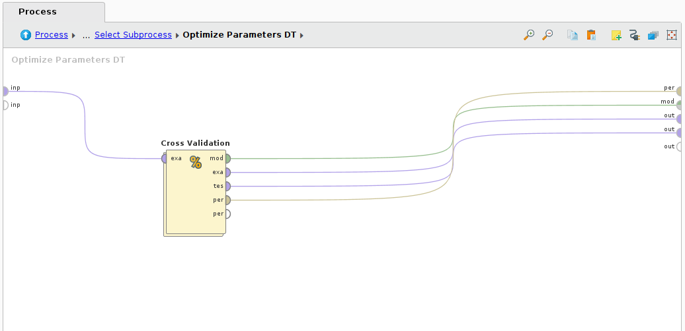

- Inside Cross Validation operator, add Decision Tree to Training part and Apply Model, Performance operators to Testing part.

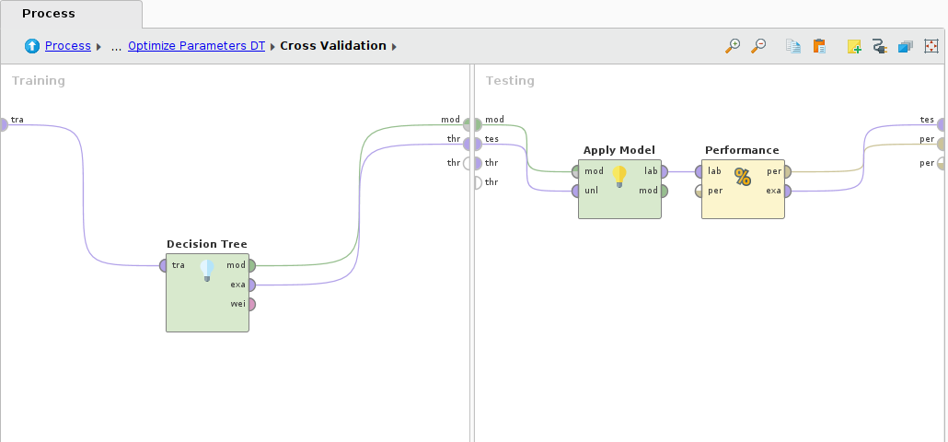
- Similarly add Random Forest and Rule Induction operators.

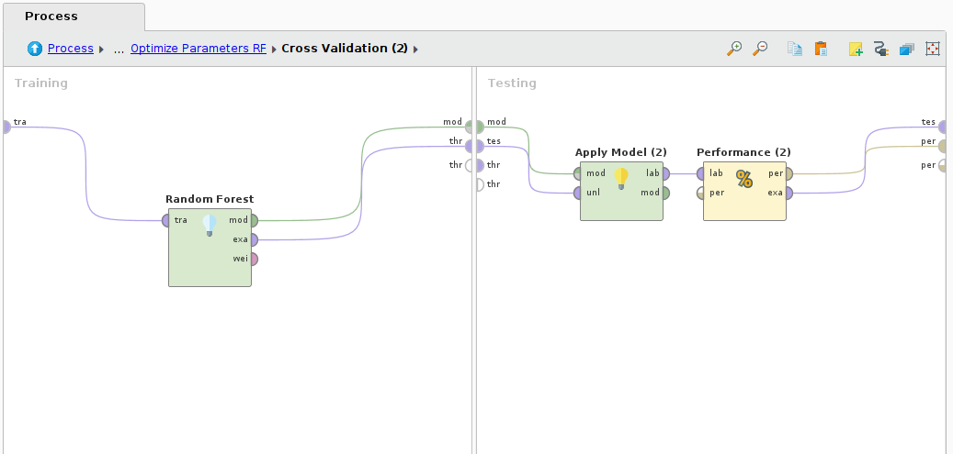
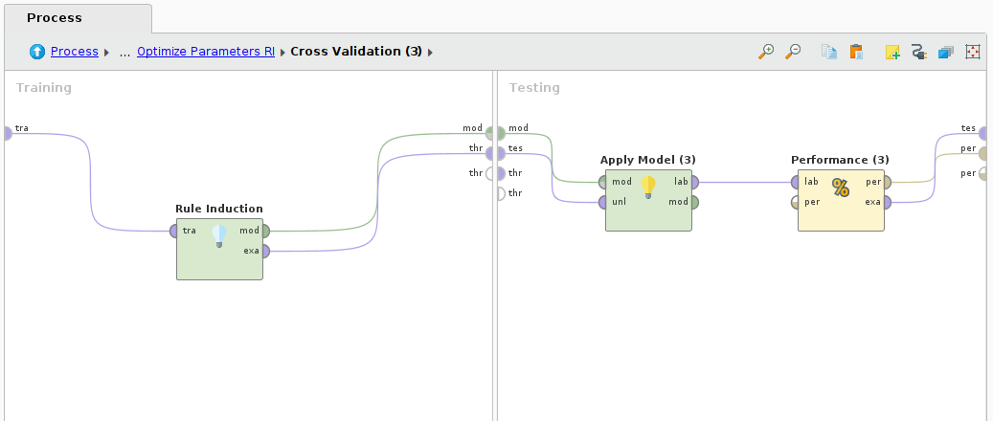

- Now, add Compare ROCs operator to the another output port of Multiply Operator.
- Inside Compare ROCs operator, add Decision Tree, Random Forest and Rule Induction operators one by one.
- Add 3 sets of Recall operator and Set Parameters Operators to inside the Compare ROCs operator one each for Decision Tree ROC, Random Forest ROC and Rule Induction ROC.
- In parameter of Recall operator, name is same as that of Remember operator.
- In parameter of Set Parameters, go to Edit List > set operator name as Optimize Parameters and Operator name as current operator name.

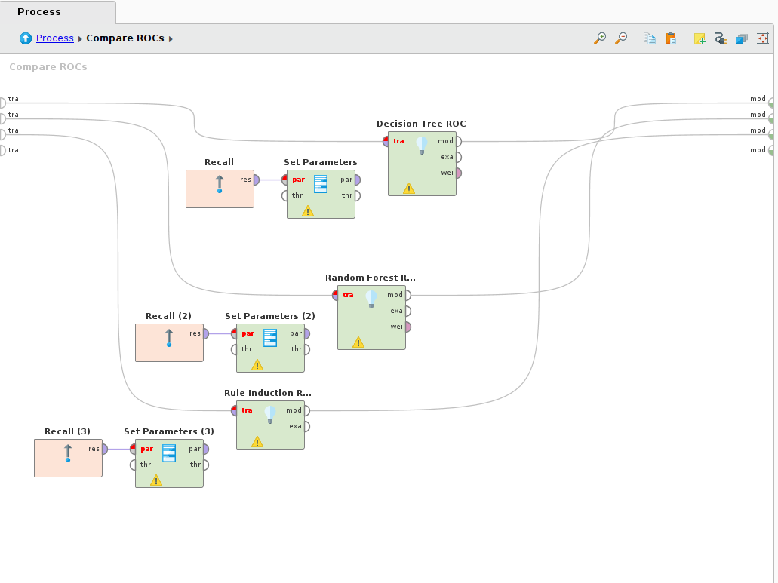
- Here, In this dataset, the attribute Faculty_Performance is not Binomial, hence, We are not going to use it as Compare ROCs operator only supports Binomial attributes.

Statistics

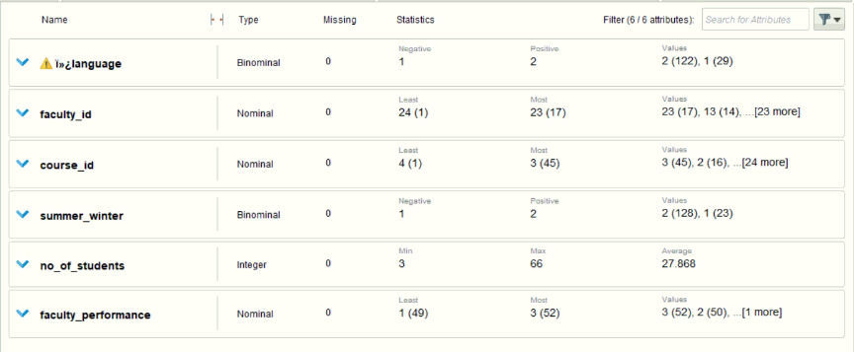

Result

This graph shows the accuracy of Optimize Parameters DT.

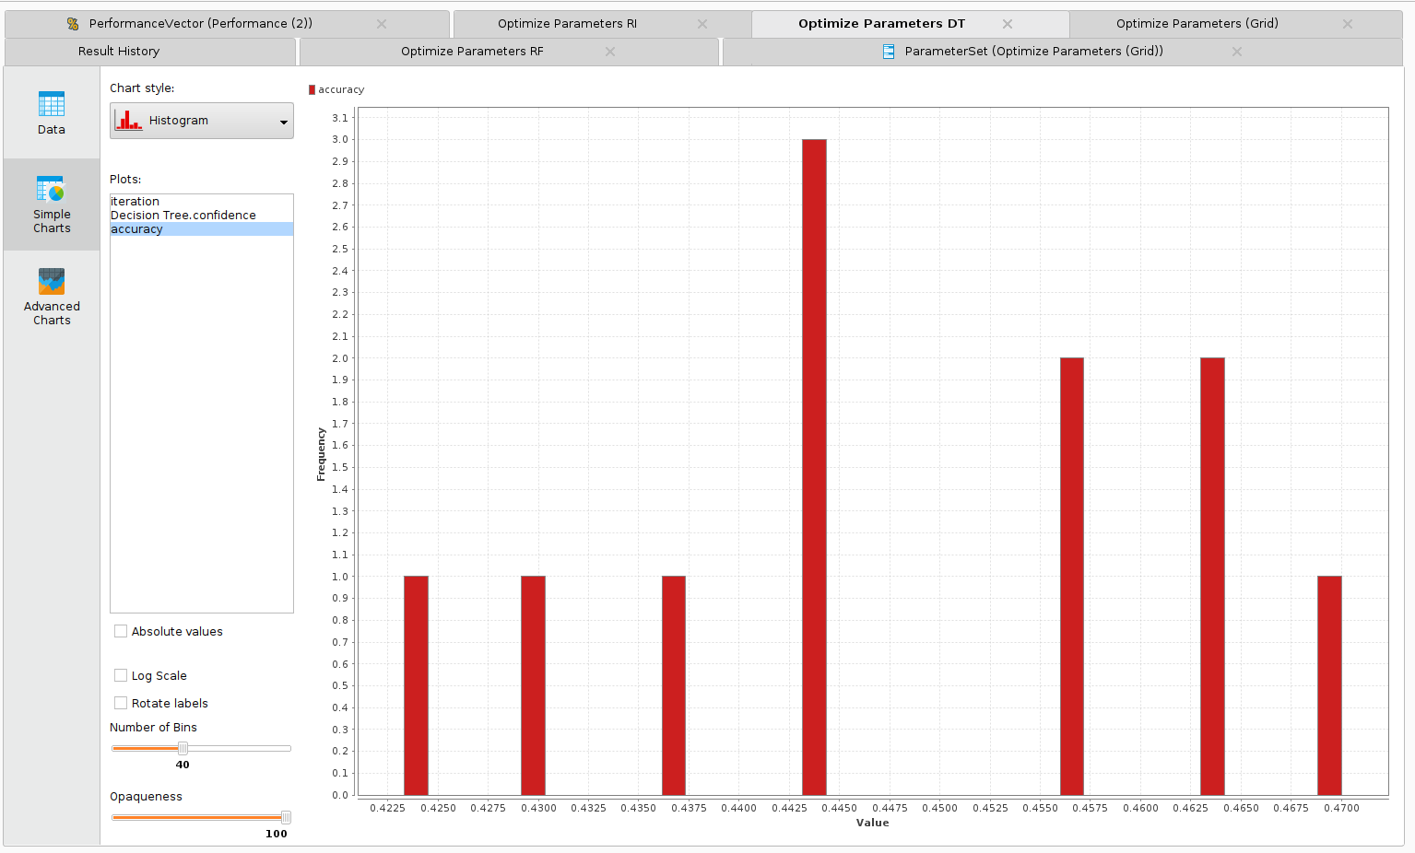

This table shows the accuracy of the classification model.
Here it is 62.88%.
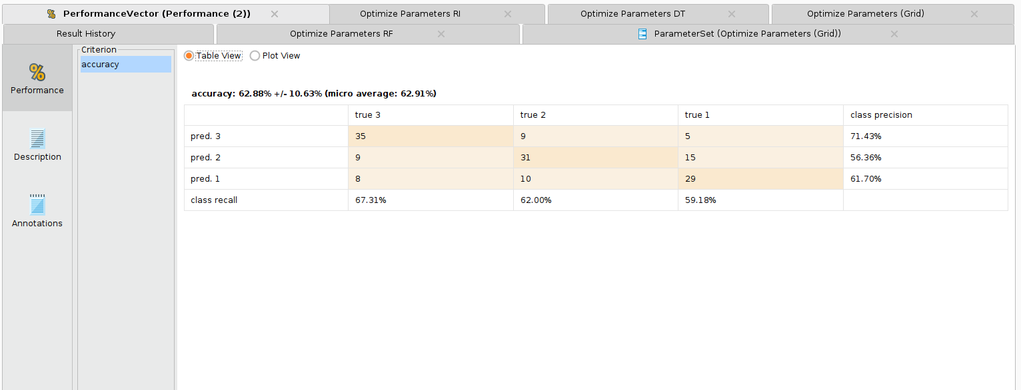

This is the confusion matrix of the Performance Vector.

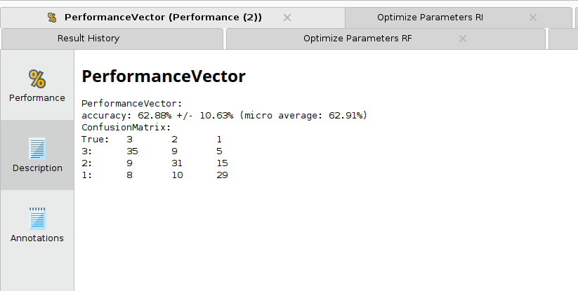

This is the value of accuracy and confidence of Decision Tree in each iteration.

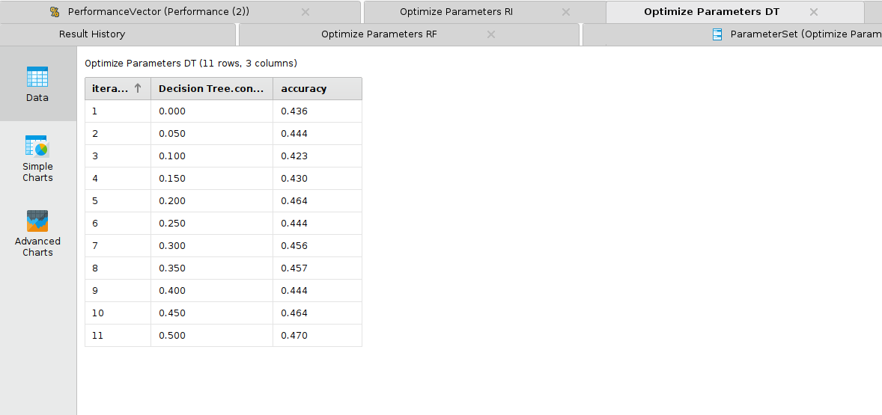

This is the value of accuracy and confidence of Decision Tree in each iteration.
